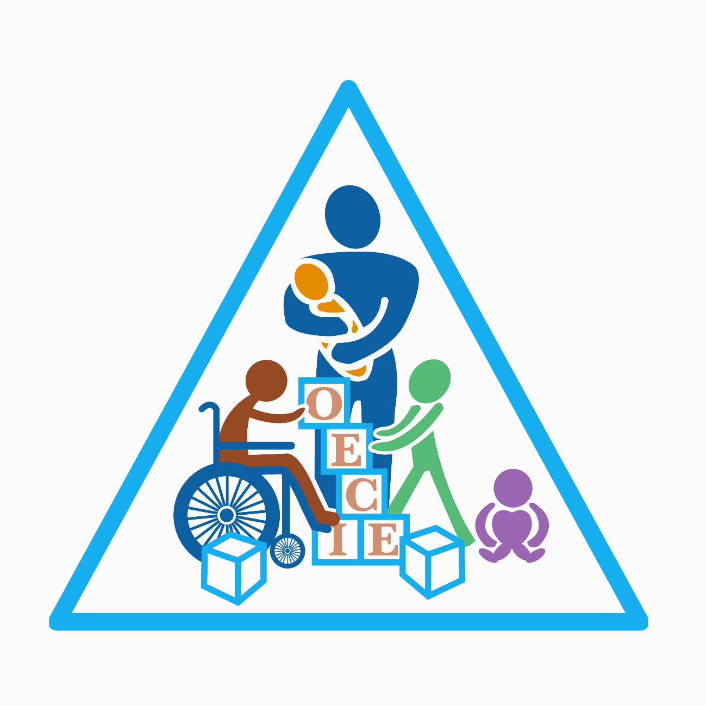

Orana Early Childhood Intervention
2024 Scholarships
Open 25 March 2024
Closing 31 May 2024

Orana Early Childhood Intervention (OECI)
OECI is a Not-for-Profit Community organisation and a registered NDIS provider based in Dubbo NSW.
The Orana Early Childhood Intervention & Education Project Inc, began in 1984 following a public meeting called by concerned parents & community members regarding the lack of Early Intervention services in the Orana Region. Funding was secured by these parents and community members and the Project commenced.
Orana Early Childhood Intervention is an early childhood intervention service providing educational and therapeutic services to children and their families residing in Dubbo and surrounding communities. Children aged 0 – 12 years of age with developmental delay & or disability may be eligible for access.

Our aim is to provide children and their families with the opportunity to reach their full potential and be included within their community. We offer family centred practice, recognising that families are the experts in knowing and working with their child.
Educators, Physiotherapist, Occupational Therapists, Family Support Worker, and Speech Pathologists work together within a trans-disciplinary team approach to provide integrated and co-ordinated service delivery.

Orana Early Childhood Intervention offers a diverse range of service delivery to meet the individual needs of children and families accessing our service. Service delivery can include individual sessions and small group sessions & can take place within the child’s natural environment i.e. Community setting, School or Home.

Our aim for the scholarship program is to build awareness of Allied Health roles in Dubbo and the important role of Allied Health Professions play in the early years of a child’s life. As an employer OECI can offer a trans-disciplinary experience for Allied Health Professionals with expertise in Early Intervention.

Through our scholarship program we aim to encourage young people who have commenced or are continuing their university study in Allied Health, specifically, Occupational Therapy, Speech Pathology and Physiotherapy. We invite applications for our 4 scholarship opportunities.

In 2024 we will offer 4 scholarships

- 1st year Janelle Burke Scholarship $500
- 2nd Year Nola Honeysett Scholarship $750
- 3rd Year Ruth O’Brien Scholarship $1000
- 4th Year RAB scholarship $2000

Eligibility criteria
- Completed high school in Dubbo or surrounding area
- Commenced study in Occupational Therapy, Speech Pathology and Physiotherapy
- Willingness to consider a return to the Dubbo area following completion of degree

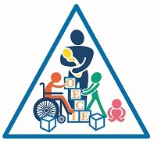
OECI Scholarship application form – www.oeci.org.au

Name : Click or tap here to enter text.

Address :Click or tap here to enter text.

Contact number :Click or tap here to enter text.

Email address :Click or tap here to enter text.

Course :Click or tap here to enter text.

University: Click or tap here to enter text. Year: Click or tap here to enter text.

HSC completed at : Click or tap here to enter text.

Why is early intervention important for childhood development?
Click or tap here to enter text.

What role does the family play in early intervention?
Click or tap here to enter text.
Tell us about your Allied Health career aspirations?
Click or tap here to enter text.
Tell us about your volunteer or community work?
Click or tap here to enter text.
Why should we select you for the scholarship ?
Click or tap here to enter text.
Would you consider working for OECI in the future ☐ Yes ☐ No
why ?Click or tap here to enter text.
Email completed application to info@oeci.org.au before 31 May 2024
* Current employees of OECI are not eligible.
Bank Details BSB Account no.

