What do we do?

Learning is for life and therefore it is important that learning is seen by your child to be enjoyable, rewarding and fun. That is why we use play to facilitate your child’s development. Play involves a child using all their capacities, whatever they may be and provides stimulation to the brain and muscles. When a child is playing they are learning how to exercise and move their muscles, learning how to move their body, solve problems, interact with other people, share and take turns. It is through play that children learn new skills, for example:
- Craft activities can assist the development of fine motor and cognitive skills
- Dress-ups can develop independent dressing skills, imaginative play, language
- Playing with a ball can develop hand eye coordination and turn taking skills

Early Childhood Intervention Teachers:
ECI Teachers address the overall developmental needs of the children. They have expertise in supporting children and their families to be included in their natural environment; care and educational service; as well as their community settings. This is done by facilitating the overall strengths, interests and needs of the child to enhance their learning and development.
ECI Teachers help children with:
- Socialisation and play skills
- Independence; self-care and emotional skills
- Communication development and following instructions
- Literacy and numeracy
- Thinking skills, attention and turn taking skills
- Physical skills and participating in games with rules
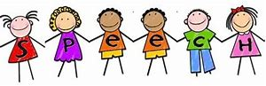
- Transition to school

Speech Pathologist:
Speech Pathologists work with you to help your child learn skills to communicate and to process information. Information and support is provided to families on how to build effective communication environments, and to help children with information processing and interaction skills.

OECI speech pathologists can help if your child is:
- Slow to start talking
- Not using a lot of words for their age
- Unclear or hard to understand
- Frustrated when they can’t get their message across
- Not following directions and instructions
- Struggling with reading, spelling or comprehension
- Finding it hard to engage with others and play with children

They also provide specialised help if your child has:
- A disability that could affect their speech or language
- Difficulty with swallowing, eating or drinking
Our Speech Pathologists help children find the best way to communicate to meet their needs. This might be through signs, symbols, gestures and other forms of assisted communication i.e. communication boards or specialized devices.
Occupational Therapist:
The goal of occupational therapy at OECI is to enable children to participate in all activities in daily life.
Why is it called Occupational Therapy? “In occupational therapy, occupations refer to the everyday activities that people do as individuals, in families and with communities to occupy time and bring meaning and purpose to life. Occupations include things people need to, want to and are expected to do.” (WFOT – World Federation of Occupational Therapists)
OECI Occupational Therapists work with you to help your child participate in and build independence in everyday activities such as;
- Dressing, mealtimes, self-care
- Learning and play

This may involve;
- Helping your child to use their hands to reach, hold and manipulate objects during everyday activities
- Providing specialised equipment (e.g. hand splints, wheelchairs, mealtime equipment, bathing equipment) to assist in access, participation and safety
- Providing advice about toys, activities and games suitable for your child
- Recommending adaptations to their environment in home, school or day care
- Giving your child strategies to regulate their emotions

Occupational therapists can also support a child who may have social, sensory or behavioural challenges that impact on their comfort, sense of security and interactions with those around them.
Physiotherapist: 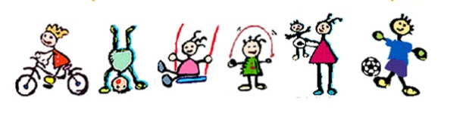
At OECI our Physiotherapist focus is on the development of movement.
Movement is an important aspect of development for babies and children. Movement allows babies and children to explore their bodies, their environment, and all the things in their world. Being able to move easily and successfully is essential for learning and growing.
Our Physiotherapist works with you and helps your child to improve their ability to move and participate in all the things they need and want to do, like playing, learning, going to school, and being part of a family and community.
She works with you to improve your child’s gross motor development including:
- Strength Range of motion
- Endurance
- Gait difficulties
- Balance and coordination
- Age appropriate specific skills development e.g. ball skills, jumping, hopping, riding a trike, climbing etc.

